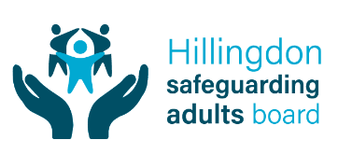
Conclusion of the Adult LADO Process
Section 1 should be completed by the employer, student body or voluntary organisation AFTER an investigation has concluded, and should be sent to the Adult LADO for review. The outcome of any police investigation should be taken into account in making a recommendation.
Section 2 should be completed by the Adult LADO when they make a final determination on the Adult LADO outcome and any agreed actions for any relevant organisation.
Section 1. Recommendations and record of actions by employer, student body or voluntary organisation.
Recommended Adult LADO Outcome
Following completion of the investigation please indicate which outcome to the Adult LADO process you are recommending. The Adult LADO will review your recommendations and rationale and will reach a final decision on this.

Malicious  The allegation was deliberately and purposefully untruthful | ☐
False  the person reporting is mistaken in what they have alleged | ☐
Unsubstantiated  there is insufficient evidence to refute/support the allegation | ☐
Substantiated  that there is evidence that the alleged incident occurred | ☐

Please give your reasons for your recommendation.
This could include the outcome of any police investigation or investigation by employer, student body or voluntary organisation.

What actions have or will be taken to safeguard any adults at risk?
This can include any action taken by police, referrals to any regulatory bodies or DBS, as well as any other actions.

Section 2. Adult LADO Outcome
Final Adult LADO Outcome:
This is the decision of the Adult LADO based on review of all of the information that has been available to the Adult LADO throughout the process.
Malicious  The allegation was deliberately and purposefully untruthful | ☐
False  the person reporting is mistaken in what they have alleged | ☐
Unsubstantiated  there is insufficient evidence to refute/support the allegation | ☐
Substantiated  that there is evidence that the alleged incident occurred | ☐

Summary of reasons for the decision

Section 3. Closure of the Adult LADO Process
I am satisfied that sufficient action have been taken by relevant organisations to protect adults at risk from harm based on the available information. | ☐
Date of decision to conclude the Adult LADO Process

Signed by The Adult LADO or Deputy LADO:
Date:

